**Marker Description**

For a model built in Visual 3d, a static trial is required to define the model segments. The model segments are based on a set of anatomical landmarks which define the orientation and position of segments. Once the segments are defined tracking markers are then assigned to each segment, with respect to the anatomical markers of their respective segments. For example for the shank segment anatomical markers are R_MKNEE, R_LKNEE, R_MMAL, R_LMAL and their respective tracking markers are R_LEG_1, R_LEG_2, R_LEG_3, R_LEG_4 See figure 1. The tracking markers are used in the dynamic trials to follow the movement of segments, during the dynamic trials the anatomical markers become obsolete.

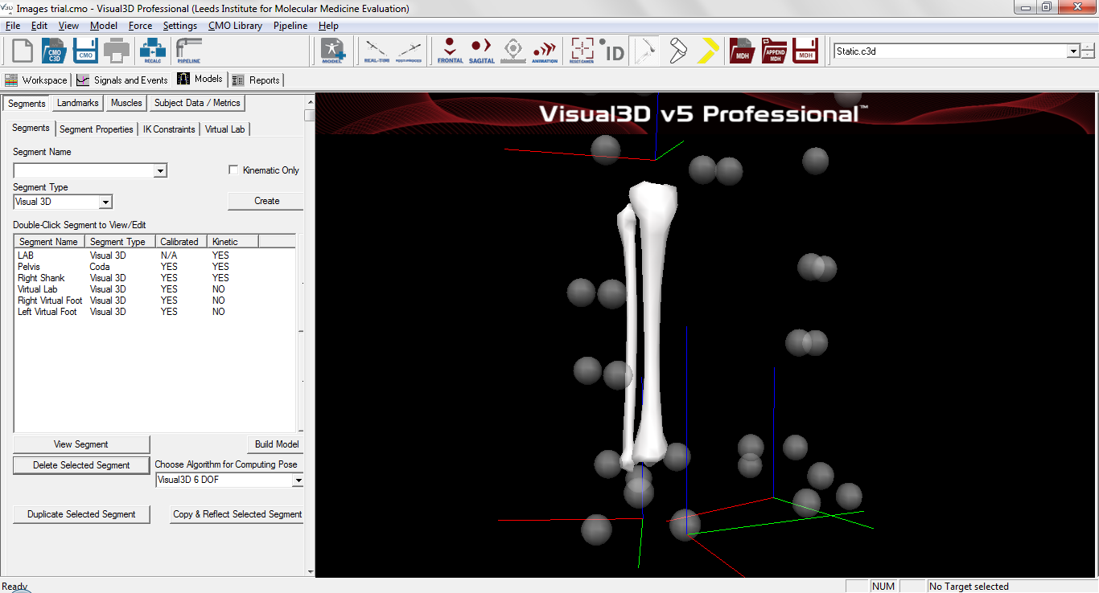

R_LKNEE

R_MKNEE

R_LEG_4

R_LEG_1

R_LEG_3

R_LEG_2

R_MMAL

R_LMAL

Figure 1. Shank modelled with anatomical markers and tracking markers

The marker list is defined below. RED indicates tracking markers used in the dynamic trials and BLACK indicates anatomical landmarks used for the static trial. We would like to know if it is possible to run the AnyBody model from the tracking markers alone, without any anatomical landmarks (beyond the initial definition of the segments)

**Upper Body**

Head-

RFHD, RBHD, LFHD, LBHD (also tracking markers)

Thorax-

STERN, T10, CLAV, RAC, LAC, C7 (also tracking markers)

All markers below are placed bilaterally.

Upper Arm-

RSHO, RMELB, RLELB,

RUARM1, RUARM2, RUARM3, RUARM4

Lower Arm-

RMELB, RLELB, RUSP, RRSP

RLARM1, RLARM2, RLARM3, RLARM4

Hand-

RM2, RM5, RUSP, RRSP

**Lower Body**

Pelvis- (Iliac crest markers are included in the c3d files however they are not used in this particular model)

LASIS, RPASIS, RASIS, LPSIS

L_PEL_U, L_PEL_L, R_PEL_U, R _PEL_L

Thigh-

R_GTROC, R_MKNEE, R_LKNEE,

R_THI_1, R_THI_2, R_THI_3, R_THI_4

Shank-

R_MKNEE, R_LKNEE, R_MMAL, R_LMAL

R_LEG_1, R_LEG_2, R_LEG_3, R_LEG_4

Foot-

R_MMAL, R_LMAL, R_HEEL_CALC, R_TOE_1_MET, R_TOE_2_MET, R_TOE_5_MET

R_HEEL_CALC, R_TOE_1_MET, R_TOE_2_MET, R_TOE_5_MET